Your Library Logo here

State of Wisconsin
DEPARTMENT OF NATURAL RESOURCES
101 S. Webster Street
Box 7921
Madison WI 53707-7921
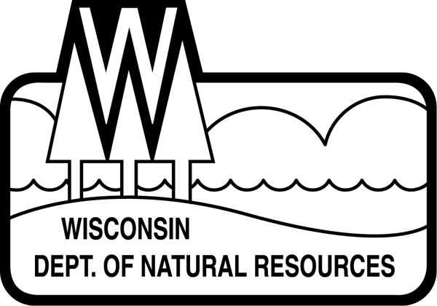

FOR IMMEDIATE RELEASE : Date
Contact: Name, title, phone #, email

Check Out Wisconsin’s State Parks At Your Library
Library Program Plans to Increase Park Access

[May 1, 2023] (MADISON, Wis.) – The Wisconsin Department of Natural Resources (DNR) and [your library here] today announced a library program to make state park and forest vehicle admission day passes available to library card holders at [your library here].

Starting after May 1st, library card holders at over 200 libraries across Wisconsin can check out a pass for free admission for one vehicle at any state park, forest, or recreation area where admission is required. The program ends December 31, 2023.

“The DNR is continually looking for innovative opportunities to bring more people to state parks and forests, and to ensure everyone in Wisconsin has access to our incredible natural resources,” said Steve Schmelzer, Director of the DNR Bureau of Parks and Recreation. “By partnering with Wisconsin’s library system, we can reach households who may not be as familiar with the wide array of opportunities Wisconsin’s state parks and forests have to offer.”

The program, Check Out Wisconsin’s State Parks At Your Library, is a collaborative effort between the DNR, Wisconsin Library Association’s Wisconsin Association of Public Libraries, Wisconsin Department of Public Instruction, and the C.D. Besadny Conservation Fund from the Natural Resources Foundation of Wisconsin.

[Insert quote from local librarian here. Something along the lines of… “Our library provides resources for everyone of all ages and backgrounds about a broad range of topics, so adding access to our state park system is a natural fit. We are excited to participate, and we hope to see this program flourish in our community. Anyone with questions about the program should stop by the library,” said (library representative name and title here).]

Along with the day pass, the cardholder will receive informational resources including state park system materials, a Wisconsin Explorer Activity Sheet, stickers, accessibility information and more. The goal of the program is to expand access to the Wisconsin state park system to new park visitors. [Your library here] received [#] passes, each with a one-time use.

The DNR plans to continue the program in 2024, based on participant feedback and funding. Each pass includes a welcome letter with a survey link so the DNR can gather information about who used the passes and how they enjoyed their park experience. Participants who complete the survey after using the pass will be eligible to win one of ten 2024 annual state park and forest vehicle admission stickers paid for by the Friends of Wisconsin State Parks.

Learn more about [your library here] and how to get a library card here. (link to your library) For more information about the Check Out Wisconsin State Parks At Your Library program, read more here.
# # # #

