Salad Bar Signage Templates:
- Print and then fill in steps 2 and 3 OR type in steps 2 and 3 and then print
- Determine the planned portion size for each item (e.g., ½ cup, ¼ cup, 1 ounce equivalent grain, 2 ounce equivalents meats/meat alternates [M/MA] servings)
  - Fill this in on the second blank
- Determine how many pieces of the item fill the selected standardized measuring utensil or meet the planned portion size
  - Fill this in on the first blank
- Production records should indicate the same portion sizes and crediting as salad bar signage Specify and standardize how items should be sliced/prepared (e.g., should bell pepper be sliced in strips or in rings? Should the oranges be halved or quartered? What case count are the apples?)
  - See Production Records webpage for production record templates, if needed
  - Utilize the Food Buying Guide as needed
  - Use Exhibit A to credit grain items, which must be whole-grain rich
  - Credit vegetables to the appropriate subgroup
    - Raw, leafy green vegetables credit as half of their volume
    - The meal planner must predetermine if beans/peas will credit as vegetable or as M/MA
- Cut pages in quarters, laminate if desired, and hang on the salad bar
- Communicate planned portion sizes with staff at POS who ensure meals are reimbursable
- Update existing signage and add more signage as necessary

Weight versus volume:
Meats/meat alternates (M/MA) is credited by weight, not by fluid ounces. Spoodles measure fluid ounces, not ounces by weight, so it is not appropriate to use a 4 fluid ounce spoodle for an intended 4 ounce (by weight) serving of M/MA. Fluid ounces are a volume measure, while ounces are a weight measure. To ensure that students are receiving the adequate amount of M/MA, weigh the M/MA and then determine which scoop will hold that weight of product. WEIGHT AND VOLUME ARE NOT EQUAL OR INTERCHANGEABLE. OUNCES ≠FLUID OUNCES

Measurement | Applicable Meal Component | Units of Measurement | Conversions | Tools Used
WEIGHT How heavy is it? | Meats/meat alternates  Grains | Ounces (oz)  Grams (g)  Kilograms (kg)  Pounds (lb or #) | 1 lb = 16 oz  1 oz = 28 g | Scale
VOLUME How much space does it take up? | Fruits  Vegetables  Milk | Fluid ounces (fl oz)  Tablespoon (T or Tbsp)  Teaspoon (t or tsp)  Cups (c)  Pint (pt)  Quart (qt)  Gallon (gal)  Liter (L) | 3 tsp = 1 Tbsp  16 Tbsp = 1 c  1 c = 8 fl oz  1 pint = 2 c  1 quart = 2 pints  1 gallon = 4 quarts | Spoodles, measuring cups, measuring spoons, scoops, dishers, ladles

Self-Serve Garden Bar

You must select at least ½ cup of fruits, vegetables, or a combination to make a complete meal

½ cup of fruit |  | Total ½ cup of fruit and vegetable |  | ½ cup vegetable
½ cup |  | 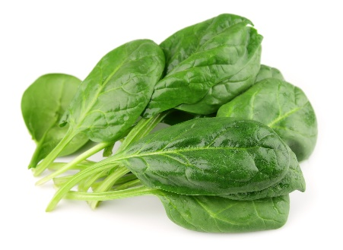  +  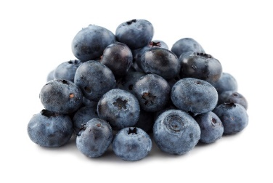  = ½ cup |  | 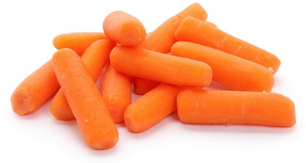  ½ cup

 | This institution is an equal opportunity provider. | July 2024

_____ pieces of BROCCOLI equals  _____ cup vegetable  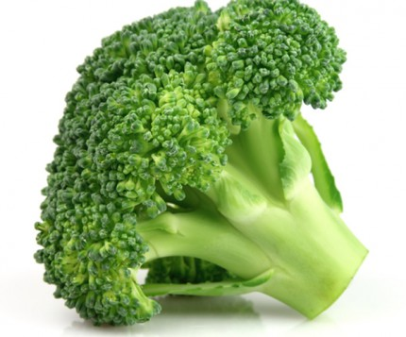 | _____ pieces of CAULIFLOWER equals _____ cup vegetable  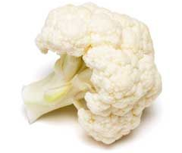
_____ CARROTS equals  _____ cup vegetable  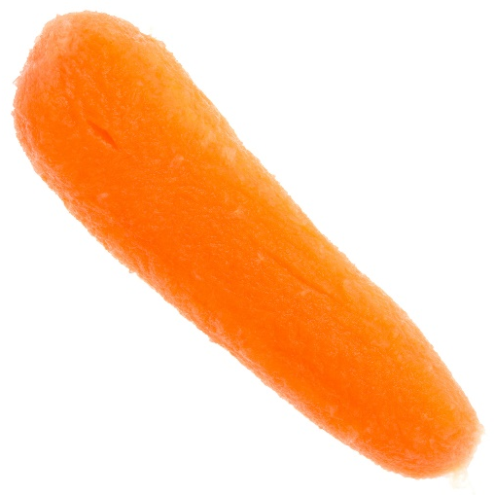 | _____ CELERY sticks equals  _____ cup vegetable  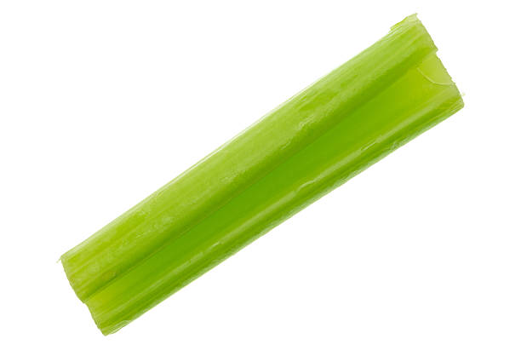
_____ pieces of CUCUMBER equals  _____ cup vegetable  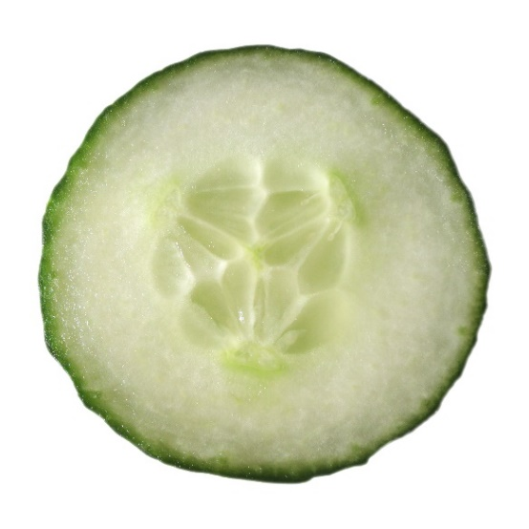 | _____ pieces of RADISH equals  _____ cup vegetable  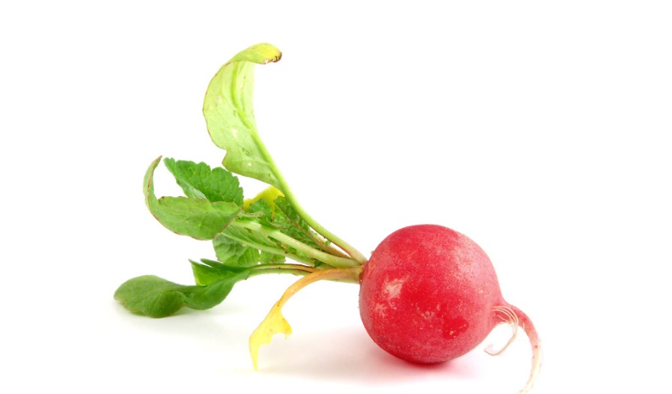
_____ pieces of PEPPER equals  _____ cup vegetable  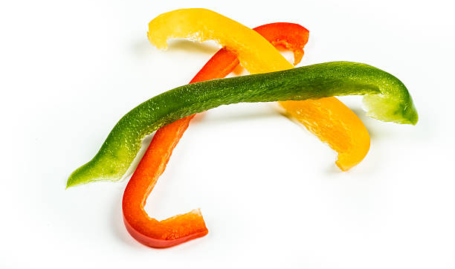 | _____ TOMATOES equals  _____ cup vegetable  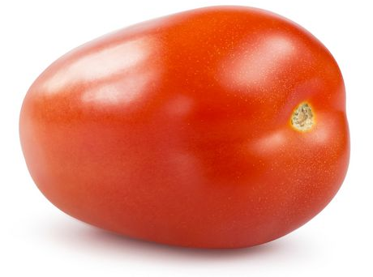
_____ MUSHROOMS equals  _____ cup vegetable  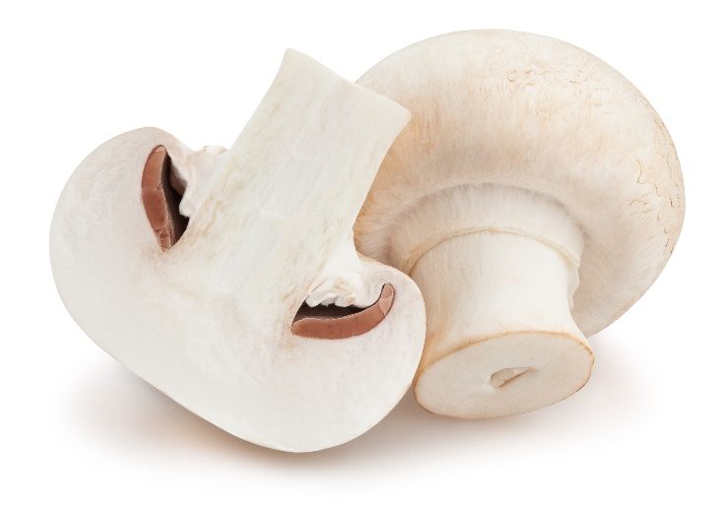 | _____ SNAP PEAS equals  _____ cup vegetable
_____ slices of APPLE equals  _____ cup fruit | _____ BANANA equals  _____ cup fruit  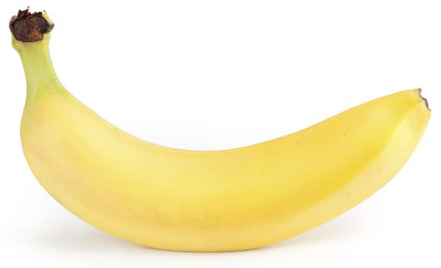
_____ GRAPES equals  _____ cup fruit  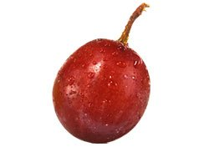 | _____ slices of ORANGE equals  _____ cup fruit  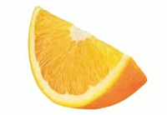
_____ slice(s) of BREAD equals  _____ servings of grains  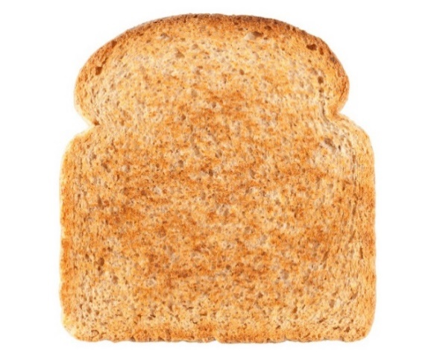 | _____ ROLLS equals  _____ servings of grain
_____ CRACKERS equals  _____ servings of grain  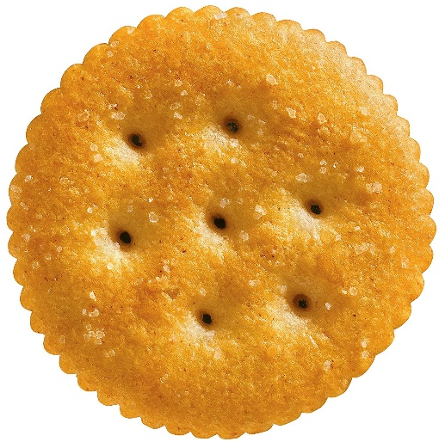 | _____ BREADSTICK(S) equals  _____ servings of grain
_____ CROUTONS equals  _____ servings of grain  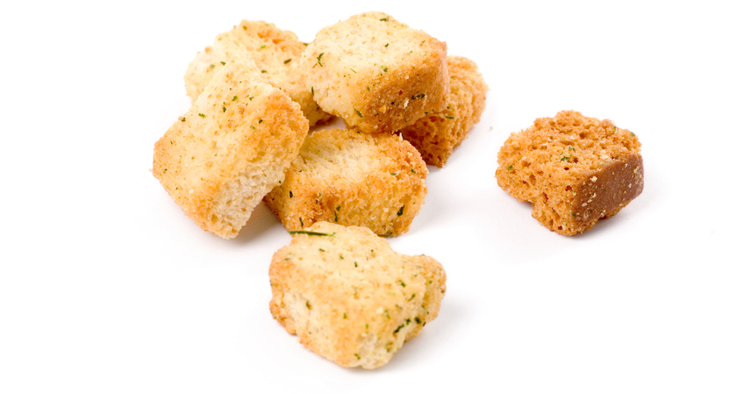 | _____ pieces of EGG equals  _____ servings of protein  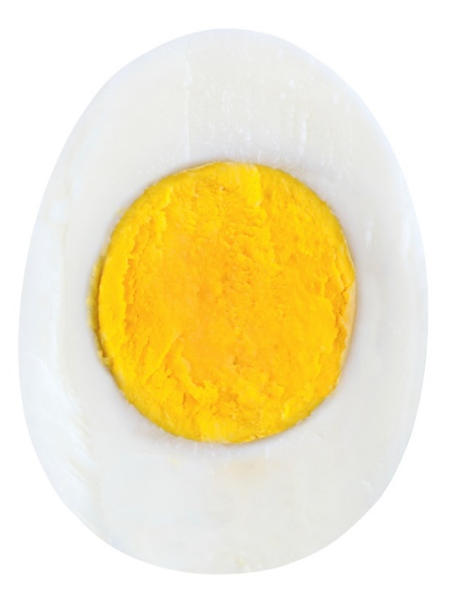
_____ pieces of CUBED CHEESE equals _____ servings of protein  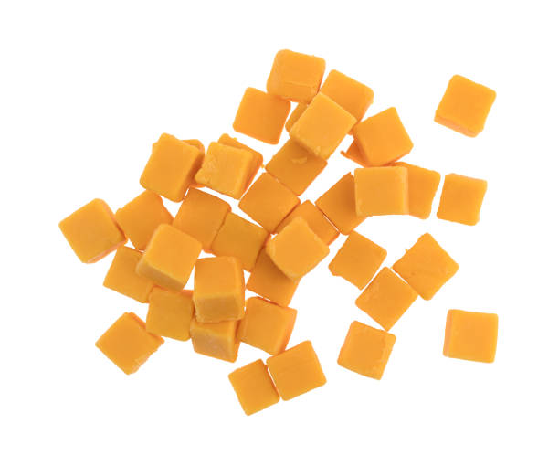 | _____ scoops of CHEESE equals  _____ servings of protein  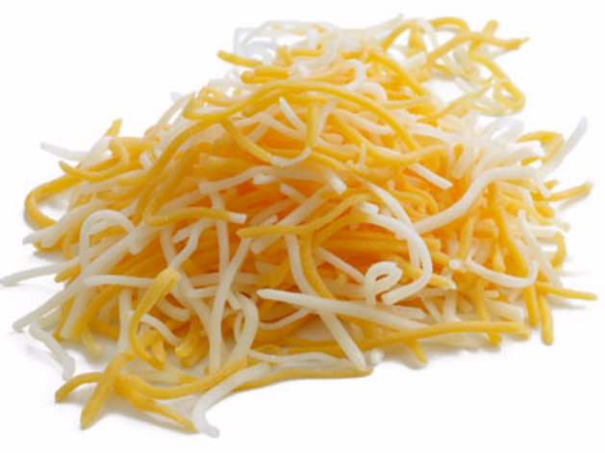
_____ scoops of MEAT equals  _____ servings of protein  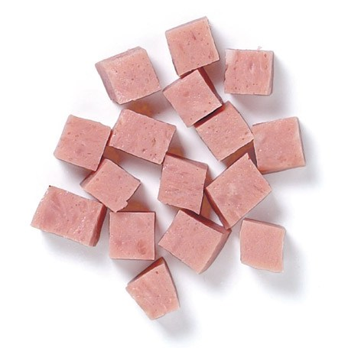 | _____ pieces of TOFU equals  _____ servings of protein  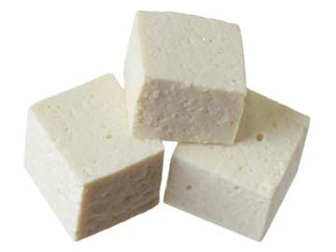
_____ scoops of BEANS equals  _____ servings of protein | _____ scoops of SPINACH equals  _____ cup vegetable  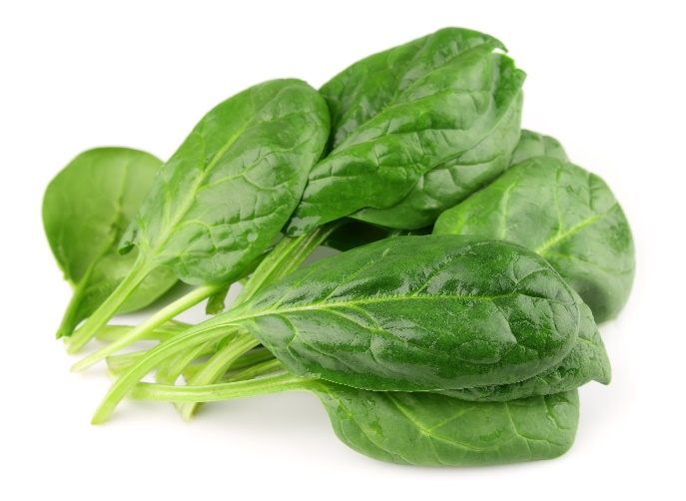
_____ scoops of LETTUCE equals
_____ cup vegetable
