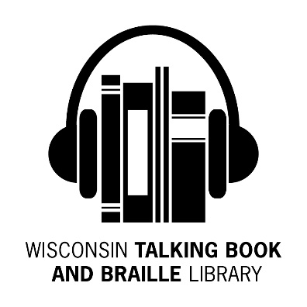
Bulletin Board
Fall 2015 Newsletter

What’s Been Happening at the WTBBL!

Hello Readers,

To celebrate their golden milestone and the opening of a digital recording center, over 200 people attended ABLE’s 50th Anniversary Celebration on Tuesday, September 29th, 2015. Details will be found at www.ablenow.org. More information about the new ABLE Sound Center will be in the next newsletter.

ABLE’s new Sound Center will help WTBBL submit more audiobook recordings to the Braille and Audio Reading Download (BARD) service, so that NLS members in any state have easy access to them.

WTBBL welcomed, Pharlin, a new Circulation Aide, in September.

You may have noticed more DBs coming to you with brailled labels. Please make note of the DB number and report to us if a label is not readable.

Keep reading and talking about us to your friends,

Linda

End of Cassette Tape Books and Yellow Players

The National Library Service (NLS) has ceased production and distribution of the cassette book collection and players.

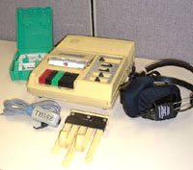
WTBBL will stop circulating books and magazines on cassette tape using the YELLOW cassette player at the end of
2015.

NOTE: Cassettes (RCs) have two holes. Most RC books come on multiple cassettes in green cases. Most patrons DO NOT receive cassettes. Digital cartridges (DBs) have one hole. An entire book fits on one cartridge. The digital book collection far surpasses the cassette collection in both quality, quantity and ease of use.

Please return your cassette player now if you are no longer using it. If you no longer have the original box, contact us and we will be happy to send you one.

Most of our library patrons have only used the BLACK digital player and digital cartridges since 2010. WTBBL will continue to circulate DB books on digital cartridge using the black digital player.
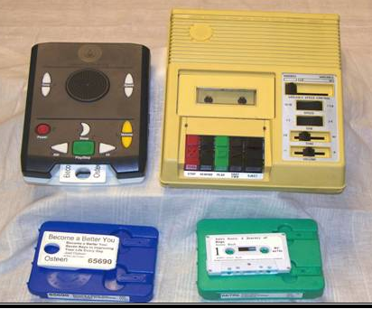

Please note:
NLS continues the Analog-To-Digital program, digitizing many of the books originally produced in the cassette (analog) format. The converted titles can be downloaded from BARD or requested on cartridge from WTBBL.

New Magazines Available

Magazines distributed on cassette have ended. WTBBL is introducing a new process for distribution of these and other digital magazine titles that have not been available on digital cartridge through the NLS magazine program.

We will be introducing our first magazine cartridge before the end of 2015. It will be a PEACH color. It will contain three magazines—Guideposts, Reader’s Digest, and Milwaukee Magazine. The three titles will come together on ONE cartridge and you will need to use the Bookshelf feature to jump from magazine to magazine. Please contact us if you would like to sign up to receive these magazines.

The cartridge loan period is 60 days. As long as you keep returning your cartridges, a new cartridge will be sent to you monthly with new issues of all three magazines.

WTBBL hopes to expand the magazine selection in the future.

Tips and Tricks Using Your Player

- If you listen to an entire book and want to start it over and listen to it again, press the green square Play/Stop button twice. This will only work after you hear End of Book.

- The Bookshelf feature is very useful when you receive a cartridge with more than one book or magazine on it.

How to use the Bookshelf feature:

- Insert cartridge in player.

- Listen to the number of items that are listed on the cartridge.

- Press and hold the green square Play/Stop button until you hear the player say Bookshelf.

- Press the white triangle RW button or the white triangle FF button to select the book or magazine on the cartridge you want to listen to.

- Then press the green square Play button to listen to the story.

WTBBL Adult Book Club

On August 18th, the WTBBL book club discussed the book The Museum of Extraordinary Things by Alice Hoffman (DB078515). We discussed some of the historical events, including the Triangle Shirtwaist Factory fire and the Dreamland fire at Coney Island, which were major events both in the book and in U.S. history. We also discussed how our perceptions (and the characters’ perceptions) of events can differ from the reality when you see the situation from another point of view.

Our next book club meeting was on October 13th. We discussed the book The Girl on the Train by Paula Hawkins (DB080635). The book was similar to Gone Girl by Gillian Flynn, 4:50 from Paddington by Agatha Christie, and Alfred Hitchcock’s Rear Window, and yet this book had an original, twists-and-turns story of its own. We discussed the difficulty of having an unreliable narrator and how jealous reactions can make situations spiral out of control.

The book club meets on the phone using a toll free phone number, on a Tuesday, every other month, and you may participate from 1:30 pm to
2:30 pm and/or from 6:30 pm to
7:30 pm. Both book clubs will read the same book and discuss it at different times on the same day.

On Tuesday, December 1st, we will discuss The Light Between Oceans by
M. L. Stedman (DB075192 / Available on BARD).

Book Synopsis: Western Australia, 1926. On an island one hundred miles from the mainland, lighthouse keepers Isabel and Tom Sherbourne discover a boat carrying a dead man and a crying baby. The decisions they make that day come back to haunt them several years later. Bestseller. 2012.

Joining the WTBBL book club is fun! You talk with interesting people. You read books that you may not consider otherwise. It can be fun to chitchat about books, upcoming events, tips and tricks to help in everyday life, and common interests.

The book club will continue in 2016. Our first meeting for 2016 will be on Tuesday, February 9th when we discuss the book Go Set a Watchman by Harper Lee (DB81896 / Available on BARD).

For more information or to sign up to participate in the book club, please contact Becky at 1-414-286-6918 or ramanz@milwaukee.gov.

WTBBL Summer Reading Program

“Every Hero Has a Story” was the theme for the 2015 summer reading program for children and teenagers. WTBBL had 21 participants--the largest group ever!

Congratulations to all of the super readers that joined the summer reading program! We hope you discovered some new books and authors to enjoy.

New Wisconsin Titles Available

ABLE (Audio & Braille Literacy Enhancement) has produced more Wisconsin books for your reading pleasure.

Here are the recent additions:

- DBC04707 Sister: An African American Life in Search of Justice by Sylvia Bell White and Jody LePage

- A Milwaukee police officer killed Daniel Bell in 1958. Sylvia Bell White and her family suspected a racial murder but could do nothing to prove it--until 20 years later when one of the involved officers came forward. Daniel's siblings filed a civil rights lawsuit against the city and ultimately won that four-year legal battle.

- DBW09406 Studying Wisconsin: The Life of Increase Lapham, Early Chronicler of Plants, Rocks, Rivers, Mounds and All Things Wisconsin by Martha Bergland and Paul G. Hayes

- This is a biography of Wisconsin's first scientist, Increase Lapham (1811-1875). Self-taught, Lapham mastered botany, geology, archaeology, limnology, mineralogy, engineering, meteorology, and cartography. His 1844 guide to the territory was the first book published in Wisconsin.

- DBW09414 Freedom Train North: Stories of the Underground Railroad in Wisconsin by Julia Pferdehirt

- People running from slavery made many hard journeys to find freedom, on steamboats and in carriages, across rivers and in hay-covered wagons. But these troubles were worth it for the men, women, and children who eventually reached freedom. Young readers (ages 7 to 12) will appreciate the "Freedom Train North" stories of fugitive slaves who found help in Wisconsin. This book was awarded the Elizabeth Burr/Worzalla Award for Children's Literature (1999). Grades 3-6 and up.
Supply of WTBBL Applications and Brochures

WTBBL updated our library and Newsline brochures in the last year. The current brochures are pictured below. The orange and white WTBBL brochure is available in English or Spanish. Please recycle the outdated blue and white WTBBL brochures and purple Newsline brochures.

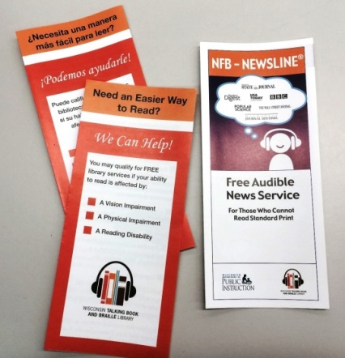

The applications did not change. Request print copies of the applications or brochures from us and/or print the individual and institutional applications from our website at http://talkingbooks.dpi.wi.gov/.

Unified English Braille (UEB) Code

On January 4, 2016—Louis Braille’s 207th birthday—the National Library Service for the Blind and Physically Handicapped (NLS) will implement the Unified English Braille (UEB) code. The new code was adopted by the Braille Authority of North America (BANA) in November 2012.

UEB eliminates some contractions and changes spacing rules to simplify the use of braille with computers, smartphones, and e-books. It will also make translating documents from braille to print or vice versa much easier.

To help readers transition to the new code, BANA has released The UEB Reader, a free hardcopy booklet with an overview of the changes and example documents to read. To request a free copy, please call Kim Charlson at
617-972-7248 and leave a message with your name, address, and phone number or send an email to kim.charlson@perkins.org.

WTBBL will be adding some new UEB braille/audio kits in the near future. Watch for more info in an upcoming newsletter.

Kindle Fire BARD App is here!

NLS reached an agreement with Amazon for a Kindle Fire (versions 2013 to present) application. This app allows patrons to download NLS books from BARD directly to their Kindle Fire.

Low Vision Support Groups

WTBBL is interested in learning about low vision support groups in the state. To help us compile a resource list of the groups, please call WTBBL or fill out a brief survey on Survey Monkey at https://www.surveymonkey.com/s/wtbblvision to answer these questions:

1. What is the name of your low vision support group?

2. Is there a special focus, age range, or audience?

3. What area in the state does your support group serve?

4. Who is the contact person and how does someone contact this person?

5. Where does the support group meet?

6. When does the support group meet?

7. Are there any member fees?

8. Is there anything else you would like to share?

Thank you for sharing information about your low vision support groups with us.

WTBBL on Facebook

WTBBL has a Facebook page to share news, photos, reviews and updates about the library. Log into
Facebook, find Wisconsin Talking Book and Braille Library and like us today!

Halloween Haunts

Here are some mysterious and spooky books you may enjoy:

- DBW00019 Maiden Rock: A Clare Watkins Mystery by Mary Logue
- DBW00030 Truth Catcher by
Anna C. Salter
- DB011121 The Amityville Horror by Jay Anson
- DB051373 The Shining by
Stephen King
- DB053404 The Year’s Best Fantasy and Horror, 13th Annual Collection edited by Ellen Datlow
- DB061446 The Mammoth Book of Best New Horror edited by
Stephen Jones
- DB061795 The Hunt Ball: A Jane Arnold Mystery by Rita Mae Brown
- DB070179 Unbelievable: Investigations into Ghosts, Poltergeists, Telepathy, and Other Unseen Phenomena, from the Duke Parapsychology Laboratory by
Stacy Horn
- DB070914 Trick or Treachery: A Murder, She Wrote Mystery by
Donald Bain
- DB80383 Krewe of Hunters,
Books 1- 5 by Heather Graham

Books for Children:

- DB062494 Orange You Glad It’s Halloween, Amber Brown? by
Paula Danziger (For Grades K-3)
- DB068099 Paddington Here and Now by Michael Bond (For Grades 3-6)

- DB058518 Bernie Magruder & the Bats in the Belfry by Phyllis Reynolds Naylor (For Grades 4-7)
- DB070363 Are You Afraid Yet? The Science Behind Scary Stuff by Stephen James O’Meara
(For Grades 4-7)
- DB049112 Sammy Keyes and the Skeleton Man by Wendelin Van Draanen (For Grades 5-8)
- DB070555 Ghost Hunters by
William W. Lace (For Grades 5-8)
- DB071787 Halloween Party: Fear Street by R.L. Stine (For junior and senior high readers)

New King James Version Bible

This is a compact audio player available to our patrons that contains the New
King James Version Bible and other books including The Conflict Of the Ages.

This compact audio player is about the size of a credit card. It is solar powered and does not need batteries. You may recharge the audio player under a lamp or by sunlight in a windowsill. Best of all, there is no charge for the player and you may keep it.

If you are registered with the National Library Service you are qualified to receive the player.

Contact Christian Record Services for the Blind at 402-488-0981 Ext. 248.

You can visit their web site at: www.christianrecord.org

WTBBL Outreach

The WTBBL staff loves to share information about our library’s services with our users and interested people. We enjoy exhibiting at resource fairs, conferences and veterans’ events. We also provide speakers for events at schools, support groups, nursing homes, senior centers, and libraries throughout Wisconsin.

Throughout this fall and winter, WTBBL will be at over 30 events. Look for us at: the Forever Young Senior Festival in Green Bay, the Wisconsin Optometric Association Convention in Wisconsin Dells, the Fall Senior Expo in Waupun, the Fun ‘n Fit Resource Fair in Kenosha, and the White Cane Day Celebration in Milwaukee.

New Audio Described DVDs

WTBBL has over fifty new audio described DVDs that you may request.
The titles include:

- Big Hero 6 DVD00792 (Children’s)
- Penguins of Madagascar DVD00795 (Children’s)
- Muppets Most Wanted DVD00798 (Children’s)
- How to Train Your Dragon 2 DVD00800 (Children’s)
- Heaven is For Real DVD00805 (Drama)
- The Hundred-Foot Journey DVD00808 (Romantic Comedy)
- Into the Woods DVD00806 (Musical)

- McFarland, USA DVD00807 (Sports)
- Gone Girl DVD00809 (Thriller)
- Fifty Shades of Grey DVD00810 (Romance)
- The Grand Budapest Hotel DVD00814 (Comedy)
- Boyhood DVD00815 (Drama)
- Lambert and Stamp DVD00816 (Documentary)
- Wild DVD00821 (Biographical)
- Lone Survivor DVD00823 (War)
- Saving Mr Banks DVD00824 (Biographical)
- Still Alice DVD00826 (Drama)
- The Hunger Games: Mockingjay, Part 1 DVD00828 (Adventure)
- X-Men: Days of Future Past DVD00829 (Science Fiction)
- The Fault in Our Stars DVD00832 (Romance)
- Selma DVD00835 (Biographical)
- Interstellar DVD00836 (Adventure)
- Captain America: The Winter Soldier DVD00837 (Science Fiction)

If you have a copy of the large print or braille DVD catalog (updated February 2015), KEEP that copy, then request an addendum list in braille or large print or an audio cartridge (for checkout).

The audio described movies are listed on the WTBBL Catalog at https://webopac.klas.com/wi1aopac/
and you may search for an actor’s name or the movie title. Once you search for either, then under the heading Medium, click on Descriptive Video to narrow down the list.

Holiday & Post Office Closings
BULLETIN BOARD is available in large print, braille and audio editions, and is also available electronically via email and through NFB-NEWSLINE®, a newspaper by phone service.

Wisconsin Talking Book and Braille Library (WTBBL)
813 W. Wells Street
Milwaukee, WI 53233-1436

1-800-242-8822 (in Wisconsin)
1-414-286-3102 (FAX)
wtbbl@milwaukee.gov (email)
talkingbooks.wi.gov

NOTE: Even if WTBBL is open, some days the Postal Service is not. Plan ahead and request a week before any holiday to ensure having enough to read.

November 11th Post Office Closed (Veterans Day)

November 26th & 27th Library Closed (Thanksgiving)

December 24th & 25th Library Closed (Christmas Eve & Christmas Day)

December 31st & January 1st, 2016
Library Closed (New Year’s Eve & Day)

Wisconsin Talking Book and  Braille Library  813 W. Wells St.  Milwaukee, WI 53233-1436 |  | FREE MATTER FOR THE BLIND OR HANDICAPPED

