Bulletin Board
Spring 2015 Newsletter
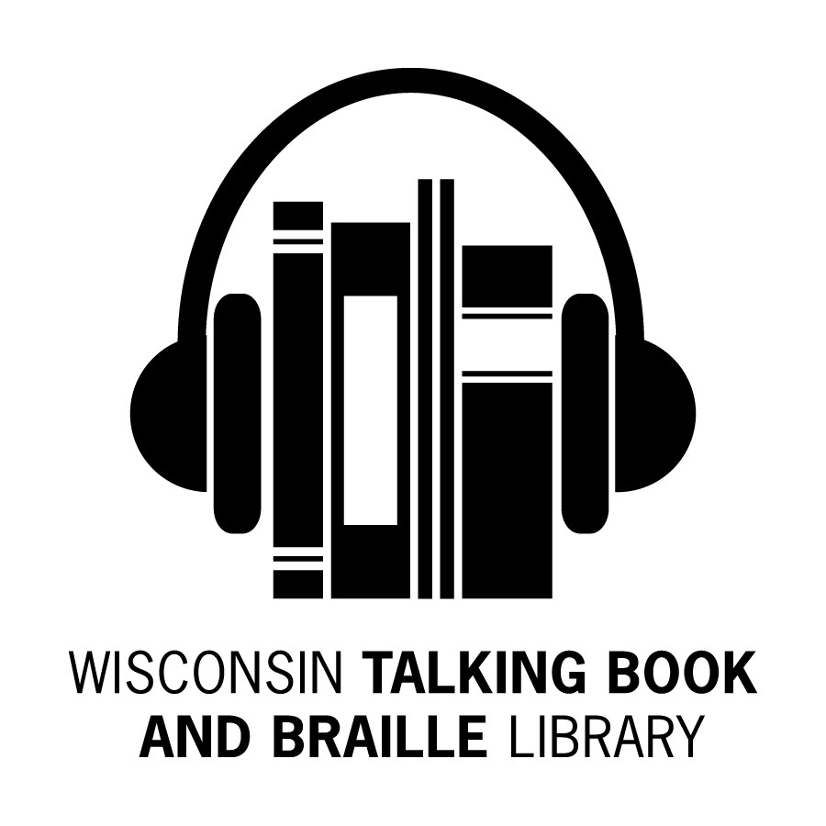

What’s Been Happening at the WTBBL!

Spring is definitely in the air. Changes continue here in WTBBL and with NLS.

There is good news regarding brailled labels for WTBBL’s locally produced cartridges. The library has ordered new printers and a computer program. You should be seeing the new labels later this year.

NLS has the Android BARD app in test mode, hoping to release it this summer.

The loan periods for NLS magazine cartridges have been changed giving you more time to listen to your titles.

If you are interested in joining a book discussion, Becky has organized two WTBBL Adult Book Clubs. There is more information in this newsletter.

Robin has joined the WTBBL staff as our Office Assistant. She was promoted from a branch library position.

Keep reading and talking about us to your friends,
Linda

WTBBL Adult Book Club

WTBBL is excited to announce that our adult book club had their first meeting in February. We discussed the book All the Light We Cannot See by Anthony Doerr (DB079182 / Also available on BARD) and had a very nice conversation about the author, plot, and characters with some time to chit chat about common interests.

Our second book club meeting will be on April 21st from 6:30 pm to 7:30 pm. We will discuss the book Gray Mountain by John Grisham (DB079768 / Also available on BARD). The book club meets by phone using a toll free phone number.

In June, we will start a second book club.
Both book clubs will read the same book and discuss it at different times on the same day.

On Tuesday, June 23rd, the first book club will meet by phone 1:30 pm to
2:30 pm. Also on Tuesday, June 23rd, the second book club will meet by phone 6:30 pm to 7:30 pm.

The upcoming book club titles are:

June 23rd: Unbroken: A World War II Story of Survival, Resilience, and Redemption by Laura Hillenbrand (DB072129 / Available on BARD)

August 18th: The Museum of Extraordinary Things by Alice Hoffman (DB078515 / Available on BARD)

We will also have book club discussions in October and December this year.

For more information or to sign up to participate in the book club, please contact Becky at 1-414-286-6918 or ramanz@milwaukee.gov.

New Wisconsin Titles Available

ABLE (Audio Braille and Literacy Enhancement) has produced more Wisconsin books for your reading pleasure.

Here are the recent additions:

- DBW09402 Occupying Aging: Delights, Disabilities, and Daily Life by Katherine Schneider

- What does a retired psychologist with a Seeing Eye dog do with her days? Warm, wise, and conversational, these 366 journal-like entries fly off the page and into your heart.

- DBW09408 Death Stalks Door County: A Dave Cubiak Door County Mystery, bk. 1 by Patricia Skalka

- Former police detective Dave Cubiak investigates the mysterious deaths that are haunting him and the tourist mecca of Door County, Wisconsin.

- DBW09409 Dead Lil’ Hustler: Loon Lake Fishing Mystery, bk. 14 by Victoria Houston

- Police Chief Lewellyn Ferris has her hands full with the discovery of the skeletal remains of two victims discovered on a hidden river deep in the national forest.

- DBW09411 My Life with the Green & Gold: Tales from 20 Years of Sportscasting by Jessie Garcia

- For twenty years, sportscaster Jessie Garcia has interviewed famous athletes and coaches. She shares a humorous insider's look at many Wisconsin teams, including the Badgers and Brewers, and Wisconsin Olympians.

- DBW09412 Myths and Mysteries of Wisconsin: True Stories of the Unsolved and Unexplained by Mike Bie

- Unearth the mysteries, strange happenings, and haunted places in Wisconsin's history. This collection of eerie stories will leave you astonished at the secrets it reveals.
- DBW09428 Civil Rights Activism in Milwaukee: South Side Struggles in the '60s and '70s by Paul H. Geenen

- Discover the challenges faced by civil rights groups in their fight for open housing and better working conditions for Milwaukee's minority community.

- DBW09433 The Quiet Season: Remembering Country Winters by Jerold W. Apps

- Jerry Apps recalls winters growing up on a farm in central Wisconsin during the latter years of the Depression and through World War II.

WTBBL Summer Reading Program

“Every Hero Has a Story” is the theme for the 2015 summer reading program. WTBBL is excited to announce that our summer reading program for children and teenagers will be starting in June.

Readers will receive sign up prizes and earn other incentives based on how many hours they read over the summer. Books or magazines in any format will count towards the total number of hours read. The grand prize will be a $50 gift card for Barnes and Noble.

If you know a child or teenager that uses WTBBL’s services and is interested in signing up for the summer reading program, please contact Becky at ramanz@milwaukee.gov or
1-414-286-6918.

Braille Games

The 13th Annual Braille Games will be held on Thursday, April 16th in Milwaukee. The Wisconsin Talking Book and Braille Library is excited to
co-sponsor this event with the Vision Forward Association and Audio & Braille Literacy Enhancement.

Children and teenagers with any level of Braille skills are encouraged to participate. The theme for this year’s Braille Games is Go to Bat for Braille! For more information, please contact Claire Egan at 414-615-0104 or
cegan@vision-forward.org.

Magazine Subscriptions

Good news if you receive magazines. NLS has extended the checkout time for magazines on cartridge.

If you receive a magazine cartridge that has only weekly magazines on it, you will have three weeks to read them instead of one week.

If the magazine cartridge has weekly and monthly magazines on it, you will have seven weeks to read them instead of four weeks.

If the magazine cartridge has only monthly magazines on it, you will have seven weeks to read them.

Please contact WTBBL if you are interested in adding or cancelling any magazine subscriptions.

The Passing of Sir Terry Pratchett

“Fantasy is an exercise bicycle for the mind. It might not take you anywhere, but it tones up the muscles that can.”

Famous and prolific author Terry Pratchett died on March 12, 2015.

Sir Terry Pratchett was 66. Pratchett wrote humorous, witty fantasy novels and he wrote them well. He is one of the most popular British authors of all time. Pratchett was knighted for services to literature in 2009.

Pratchett first published The Carpet People in 1971. He won the Carnegie Medal in 2001 for The Amazing Maurice and his Educated Rodents (DB055211).

Over the course of 40 years, the author published more than 70 books in 38 languages with total sales exceeding 85 million copies. Pratchett continued to write after being diagnosed with early-onset Alzheimer’s disease in his fifties and published multiple books after his diagnosis.

Most known for his Discworld series, Pratchett began the series with the publication of The Color of Magic (DB060775) in 1983. The fortieth book in the series, Raising Steam (DB078642), was published in 2013.

WTBBL has a number of books by and about Terry Pratchett. Please contact WTBBL if you would like to request any of his books.

WTBBL Outreach

This winter WTBBL has exhibited at a number of fun events including the Foundation Fighting Blindness Wisconsin Vision Seminar, Blackhawk Technical College’s Veterans Resource Fair, a Lions Club District Convention, and the Watertown Wellness Expo.

This spring we are looking forward to sharing information about WTBBL with more people at upcoming events. Look for WTBBL at the UWGB Pride Center Inclusivity Health and Art Fair, the Washington County Senior Conference, MS Walks throughout Wisconsin, and the Spring Senior Expo in Beaver Dam.

WTBBL would be happy to exhibit at resource fairs, conventions, conferences and veterans’ events and may be able to provide speakers for events at schools, libraries, support groups, nursing homes, senior centers, and libraries throughout the state.

If you would like WTBBL to provide a speaker at your support group or facility, to exhibit at your event, or to be represented in a resource guide, please contact us.

New Audio Described DVDs Available

WTBBL has 30 new audio described titles available on DVD. Here is a selection of the new DVDs:

• DVD00760 Rio 2 (Family)

• DVD00768 Percy Jackson: Sea of Monsters (Family)

• DVD00771 Life of Pi (Drama)

• DVD00772 Beasts of the Southern Wild (Drama)

• DVD00773 22 Jump Street (Comedy)

• DVD00775 Wolverine (Action)

• DVD00778 Separating Twins (NOVA)

• DVD00779 What are Dreams? (NOVA)

• DVD00787 How Smart are Animals? (PBS)

• DVD00789 3D Spies of WWII (PBS)

Please contact WTBBL if you would like to order a DVD catalog. We have the catalog available in large print, braille, and digital cartridge formats.

Important note: The February 2015 Audio-Described DVD Catalog is the last FULL catalog, so don’t discard it. In the future, WTBBL will send supplements when new DVDs are added to the collection.

Common Questions About Books on Digital Cartridge

Q: How long can books on digital cartridge be checked out?

A: Digital books can be checked out for 60 days.

Q: How can I tell when my digital cartridges are due?

A: The date the cartridge is sent appears on the bottom of the mailing card. The item is due 60 days after the item is mailed.

Q: What happens if I want to keep the digital book longer?

A: Digital cartridges can be renewed once, for an additional 60 days. You may call or email WTBBL and request the item be renewed for an additional 60 days.

Q: Do I need to rewind the digital cartridges?

A: No. The item will start at the beginning of the book in a different machine.

Q: What should I do if the book has a problem?

A: Please mark an X by the word Damaged in the top left corner of the mailing card on the same side as the library’s address. You may contact WTBBL to request a replacement.
Q: How do I return my items?

A: When you receive the item, the mailing card will have your name and address facing up. There will be a small punched hole in the top right corner of the card.

When you return the item, flip the mailing card over. WTBBL’s name and address will be face up. The small punched hole will be in the top left corner of the card.

The cards have Free Matter For the Blind or Handicapped on them in place of a stamp. Postage is prepaid.

Orbit iBill Currency Reader

The National Library Service has partnered with the Federal Bureau of Engraving and Printing (BEP) to distribute the Orbit iBill currency reader for free to blind and visually impaired individuals.

You may download the application from the BEP website at www.moneyfactory.gov/uscurrencyreaderform.html

You may call WTBBL and request a printed copy of the application.

Please note that reading or physical disabilities are not qualifying conditions for the iBill currency reader.

If you are having technical difficulties with your currency reader or if you ordered your currency reader longer than eight weeks ago and have not received it yet, please call the BEP Call Center at
1-844-815-9388. The Call Center is open Monday through Friday, 8 am to 4 pm.

WTBBL on Facebook

WTBBL now has a Facebook page to share news, photos, reviews and updates about the library. Log into Facebook, find Wisconsin Talking Book and Braille Library and like us today!

Low Vision Support Groups
WTBBL is interested in learning about low vision support groups in the state. We would like to compile a resource list and ask that you call WTBBL or fill out a brief survey on Survey Monkey at https://www.surveymonkey.com/s/wtbblvision

WTBBL would like to know:

1. What is the name of your low vision support group?

2. Is there a special focus, age range, or audience?

3. What area in the state does your support group serve?

4. Who is the contact person and how does someone contact this person?
5. Where does the support group meet?

6. When does the support group meet?

7. Are there any member fees?

8. Is there anything else you would like to share?

Thank you for sharing information about your low vision support groups with us.

Cassette Books and Players

The National Library Service is working on digitizing all books in the collection and is phasing out cassettes. The collection we have in digital far surpasses the cassette in both quality and quantity.

Please return your cassette player if you are no longer using it. We will be happy to send you a box to return it, if you no longer have the original box.

Do you need a large print Bible?

The Xavier Society for the Blind is considering re-publishing the large-print edition of the USCCB translation (the Catholic Bible approved by the US Conference of Catholic Bishops) of the Bible. Xavier’s large-print Bible is printed at 22 point type, while most commercial Bibles are not larger than 14. If interested, contact the Society directly at: (212) 473-7800 or www.xaviersocietyfortheblind.org

Holiday & Post Office Closings

Please note even if WTBBL is open, some days the Postal Service is on holiday. Request your books a week before the holiday to make sure you have plenty to listen to over the holidays.

May 25th Library Closed (Memorial Day)

July 3rd Library Closed (Independence Day)

September 7th Library Closed (Labor Day)

October 12th Post Office Closed (Columbus Day)

November 11th Post Office Closed (Veterans Day)

November 26th & 27th Library Closed (Thanksgiving)

December 24th & 25th Library Closed (Christmas Eve and Christmas Day)

December 31st & January 1st, 2016
Library Closed (New Year’s Eve and New Year’s Day)
Wisconsin Talking Book and  Braille Library  813 W. Wells St.  Milwaukee, WI 53233-1436 |  | FREE MATTER FOR THE BLIND OR HANDICAPPED
BULLETIN BOARD is available in large print, braille and audio editions, and is also available electronically via email and through NFB-NEWSLINE®, a newspaper by phone service.

Wisconsin Talking Book and Braille Library (WTBBL)
813 W. Wells Street
Milwaukee, WI 53233-1436

1-800-242-8822 (in Wisconsin)
1-414-286-3102 (FAX)
wtbbl@milwaukee.gov (email)
talkingbooks.wi.gov

