Virtual Spring Snapshot Prep
Q&A Sheet
May 10, 2024

Q: Can you explain in detail difference bet Food Service and Economically disadvantaged? We use Skyward SMS 2.0. We don't specifically enter Econ Dis into Skyward. I think everything for both of these are pulled from Food Service Lunch Code. Should we be doing something different? I'm with Waterford Graded School District and we are not a CEP school
A: A student’s economic disadvantage status is calculated using two different values – the student’s demographic econ status and the student’s food service eligibility record. The demographic econ status is usually collected using Direct Certification, the National School Lunch Program, or the Alternative Household Income Form. The food service eligibility is what you report as the student’s lunch program – full, free, or reduced. The reason both of these values are important is due to the reporting of CEP schools, which allow free lunch for all students, so the demographic econ status is ultimately what determines the student’s calculated Economic Disadvantaged Status.
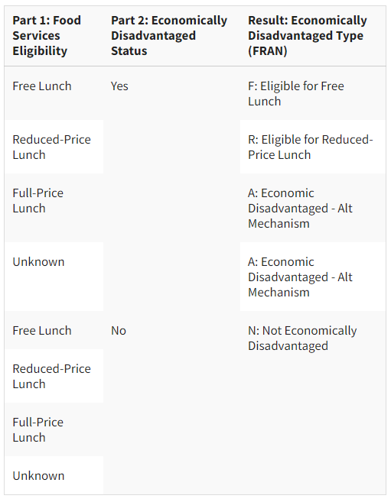

Q: In WISEdash once you have your rows selected and you click on the count of students to view the roster of kiddos in that filter, can you export or print that list of kiddos?
A: Yes! Once you have the student link, you can use the blue “Send” button in the upper right corner of the graph to download the student list.
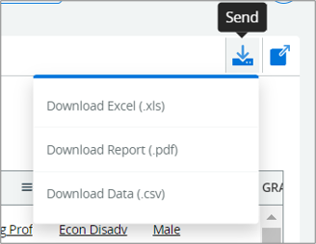

Q: Did you cover this topic? Can you explain in detail the difference between Food Service and Economically disadvantaged? Any tips on How to fix errors for Economically Disadvantaged Errors?
A: Please see the above response for the difference between the two values and how we use them to calculate what Econ Status gets reported. We recommend using the WISEdata Portal > Exports > Student Demographics > Student Characteristics export, columns X and Y to see how the demographic econ status is being reported for each student. This is the most common reason we see incorrect student econ status reporting.

Q: When you enter a Help Desk Ticket what is the expected turnaround time for response. I've had ticket out there for almost a week.
A: When you submit a Help Ticket, it may be routed through your local CESA for first level support first. From here, it will either be responded to by the CESA or escalated to our DPI Customer Service Team for response. We try to maintain a 24–48-hour turnaround time for most of the school year but please be aware that during busier times of the school year, such as prior to the Snapshots, we may take a little longer to respond. If you are seeing a consistent delay in responses, please let us know so we can look into that for you.
It is uncommon, but occasionally a technical issue impacts our response times. Just today a technical issue was discovered that prevented us from seeing many help tickets that had been recently submitted. It appears that the issue has been resolved, and we are in the process of playing “catch-up” to answer these tickets. We apologize for this. While this problem didn’t affect every ticket submitted it did impact on a good number of customers. It is very likely that the delay you experienced was the result of this issue. Again, we are sorry.

Q: I am working on the Pupil Non-Discrimination Report and would like to include the past yearly WI Pupil Nondiscrimination Annual report but have interim staff here this year. Is there a way to get copies from DPI of this information that was submitted? Any help would be greatly appreciated. Thank you!
A: The Pupil Non-Discrimination Report is a bit out of the WISEdata realm. Please contact the DPI Special Education team: https://dpi.wi.gov/support/contact-special-education

Q: Is the school filling in the part 2 (econ status) or is that done by the parent on direct cert form?
A: This information would be provided by the parent via the form.

Q:
A:

Q:
A:

Q:
A:

Q:
A:

Q:
A:

Q:
A:

Q:
A:

Q:
A:

Q:
A:

